**Setting Up Application Environment**

**Docker CLI Installation**

|  |  |
| --- | --- |
| Date | 31-10-2022 |
| Team ID | PNT2022TMID31805 |
| Project Name | Personal Expense Tracker Application |

**Step 1:**

Go to the Official Docker Website:

https://docs.docker.com/desktop/install/windows-install/

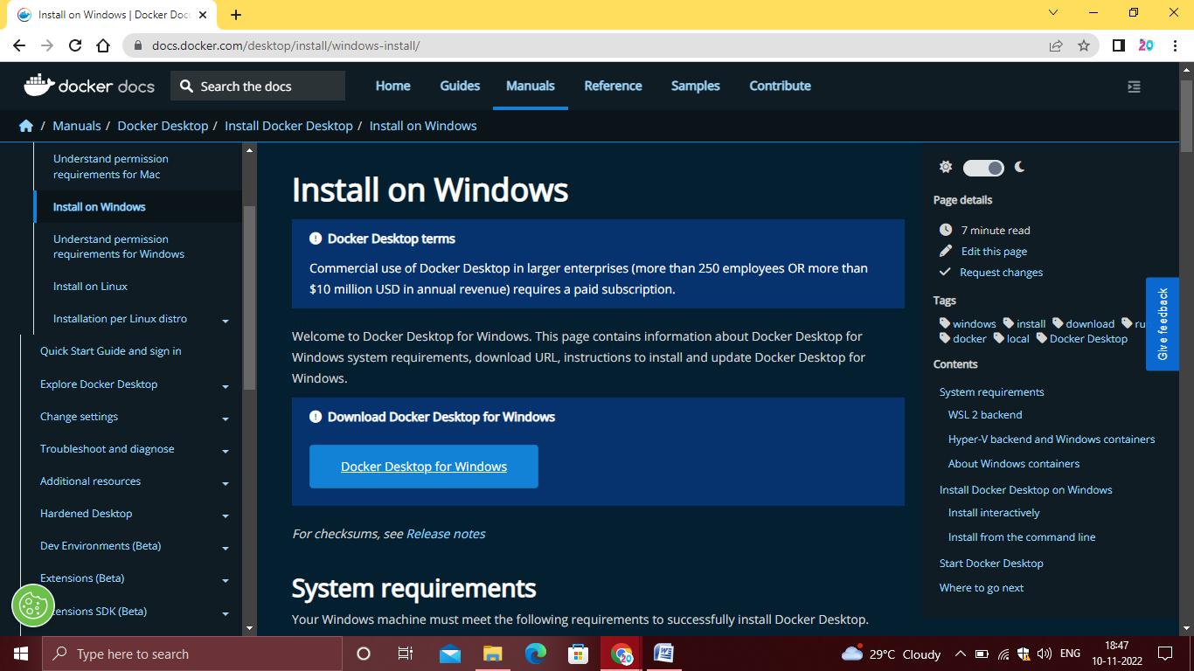

**Step 2:**

Click that button(Docker Desktop for Windows) and download will start and it takes few minutes to complete.

**Step 3:**

Go to downloads in browser(or) type ctrl+J,it will navigate to download page and double click the particular docker file.

**Step 4:**

Now Installation is Complete.This icon was added in your desktop.Double click the icon to start the docker app,you cn register and login that app to access those credentials.

**Step 5:**

Docker will start correctly,the left bottom side was shown in green color,docker will show the status of docker app working successfully.

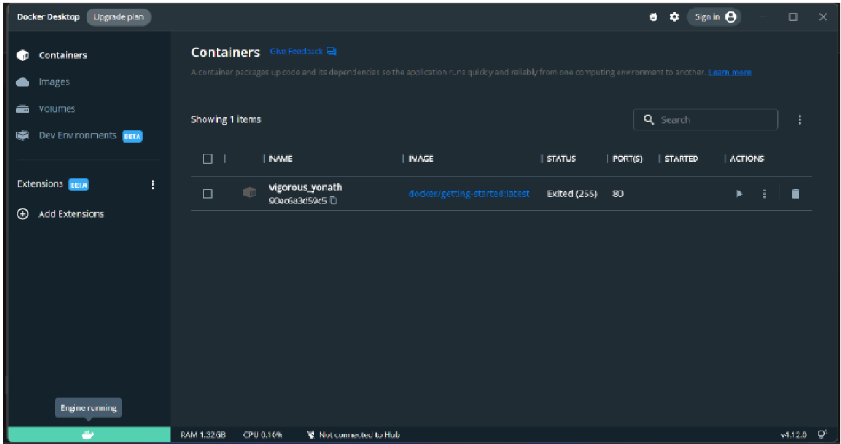

**Step 6:**

Finally ,the Docker is installed successfully.